NAME= CHINTHA DINESH

BATCHNAME= DATA ANALYTICSWITH SQL TABLEAU,PYTHON POWERBI.

DATEBATCH=20/72023

[EMAIL.COM=dineshchintha8@gamil.com](mailto:EMAIL.COM=dineshchintha8@gamil.com)

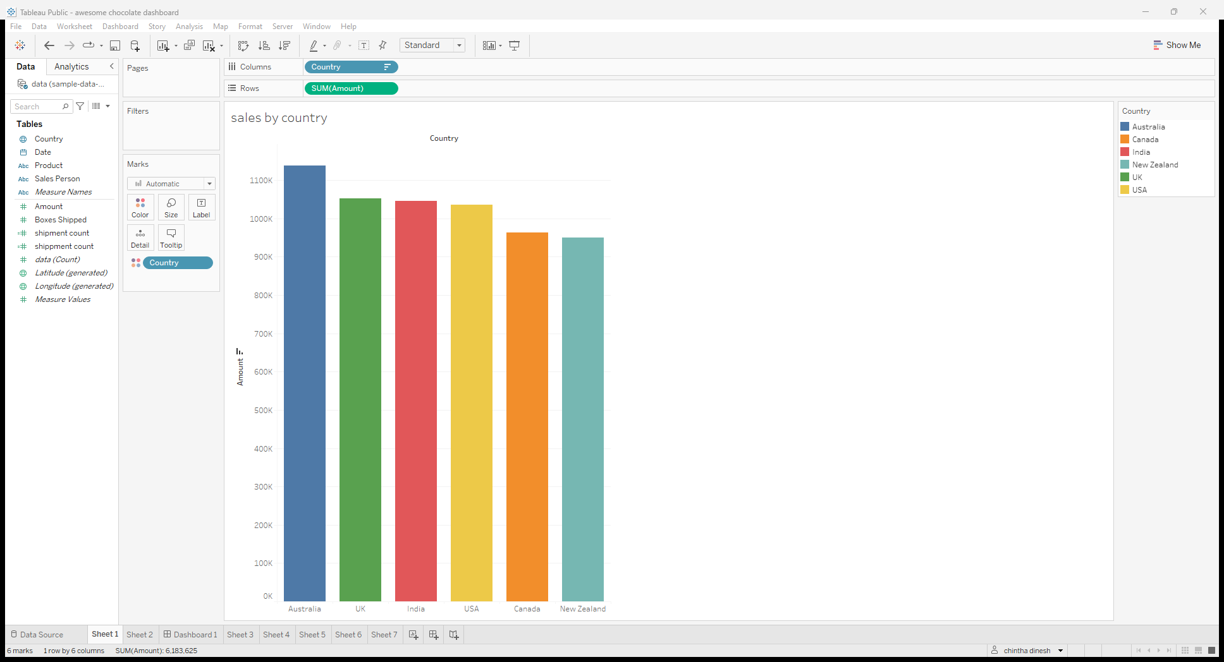Dataset= awesome chocolate from Kaggle.com

SALES BY COUNTRY

TOP10 SALES PERSONS AS AMOUNT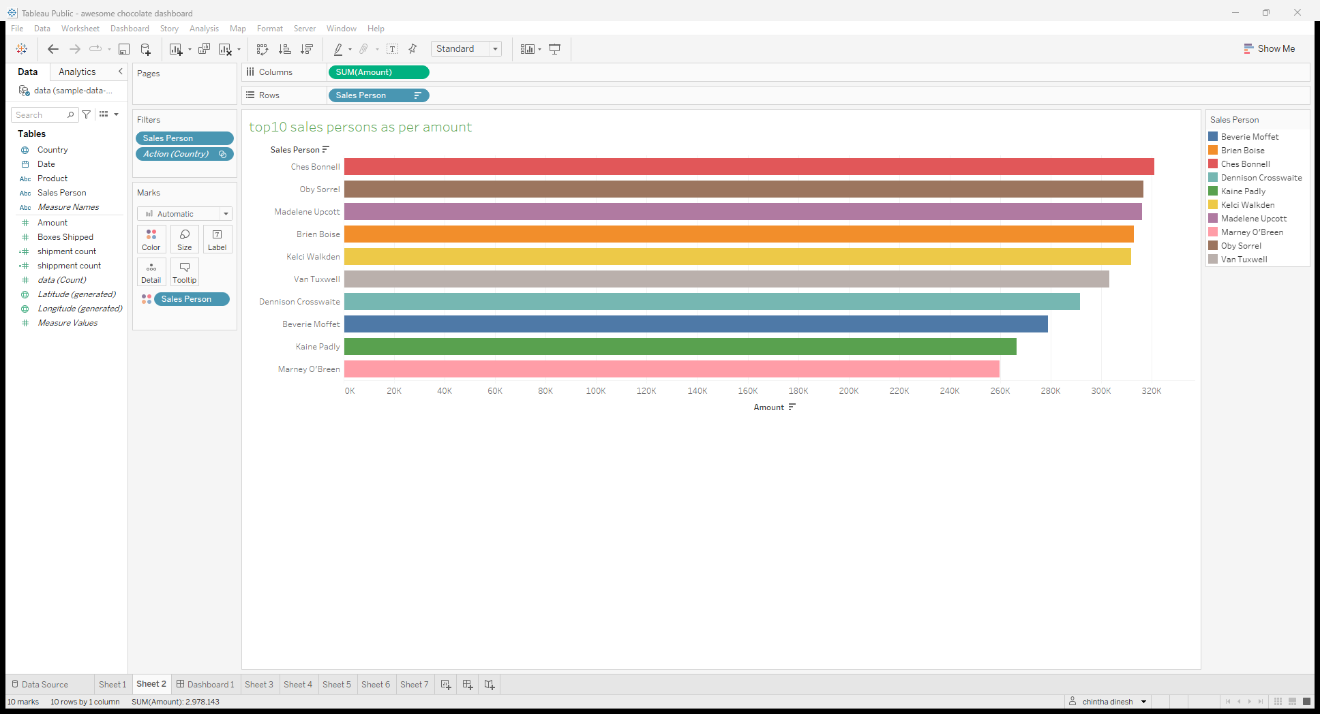

TOP5 PRODUCTS BY AMOUNT

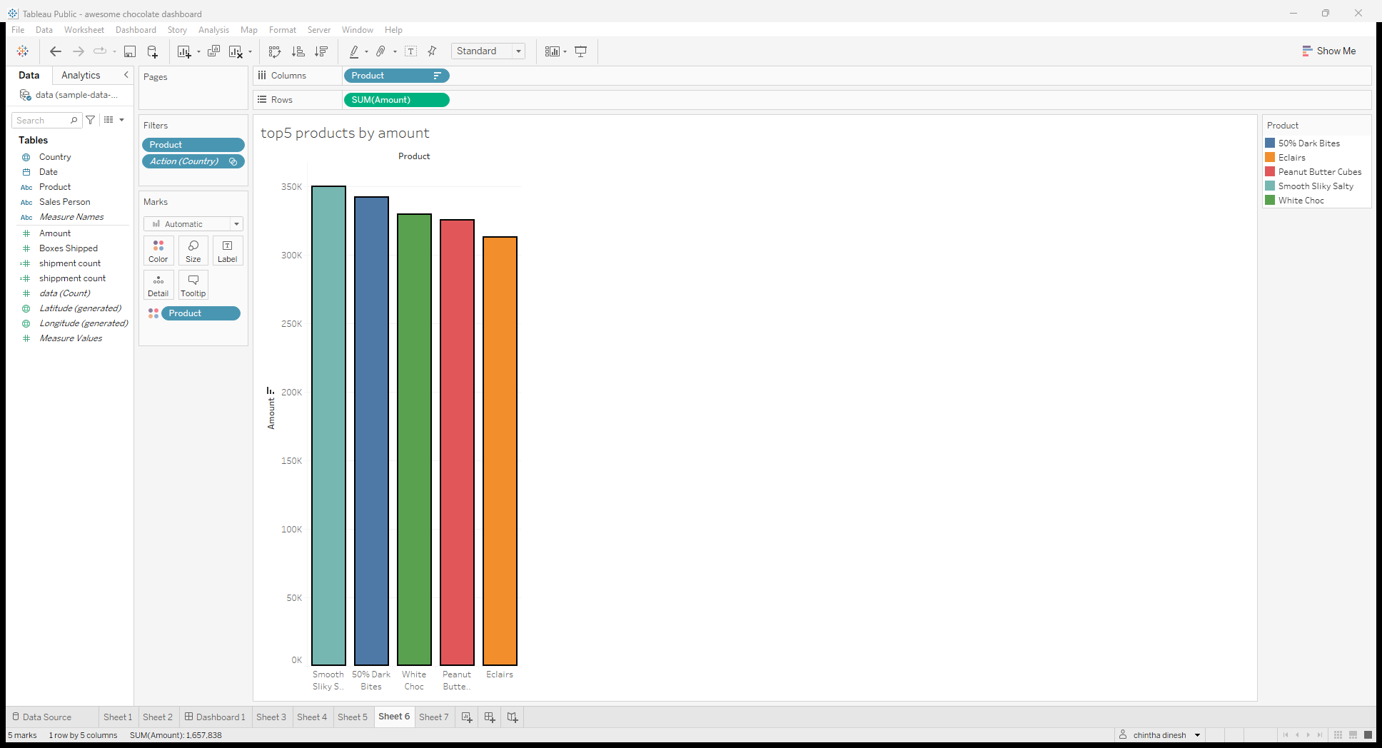

TOP15 SALES PERSONS PER BOXES SHIPPED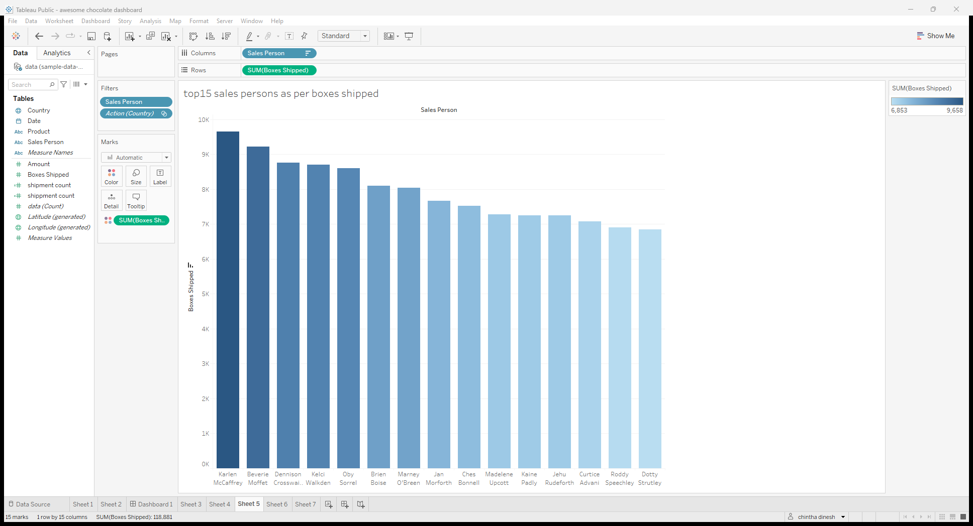PRODUCTS,AMOUNT BY WISE COUNTRIES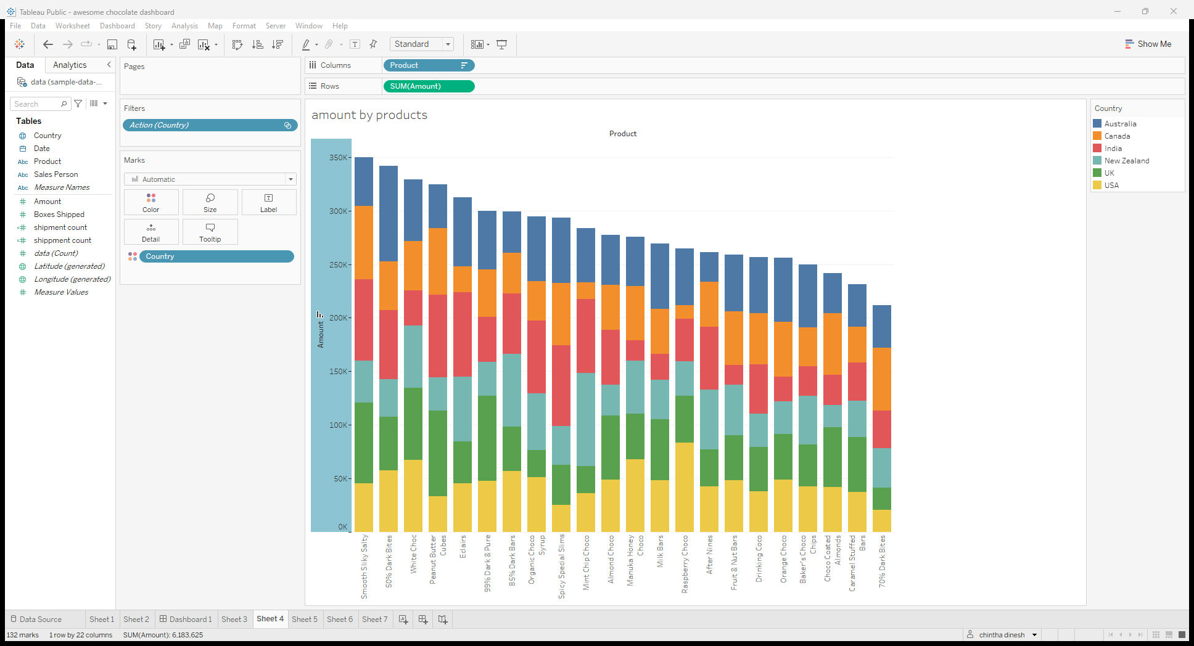

BUSINESS SUMMARY

TOTAL NUMBER OF SHIPPEDOUT,AMOUNT,BOXES SHIPPED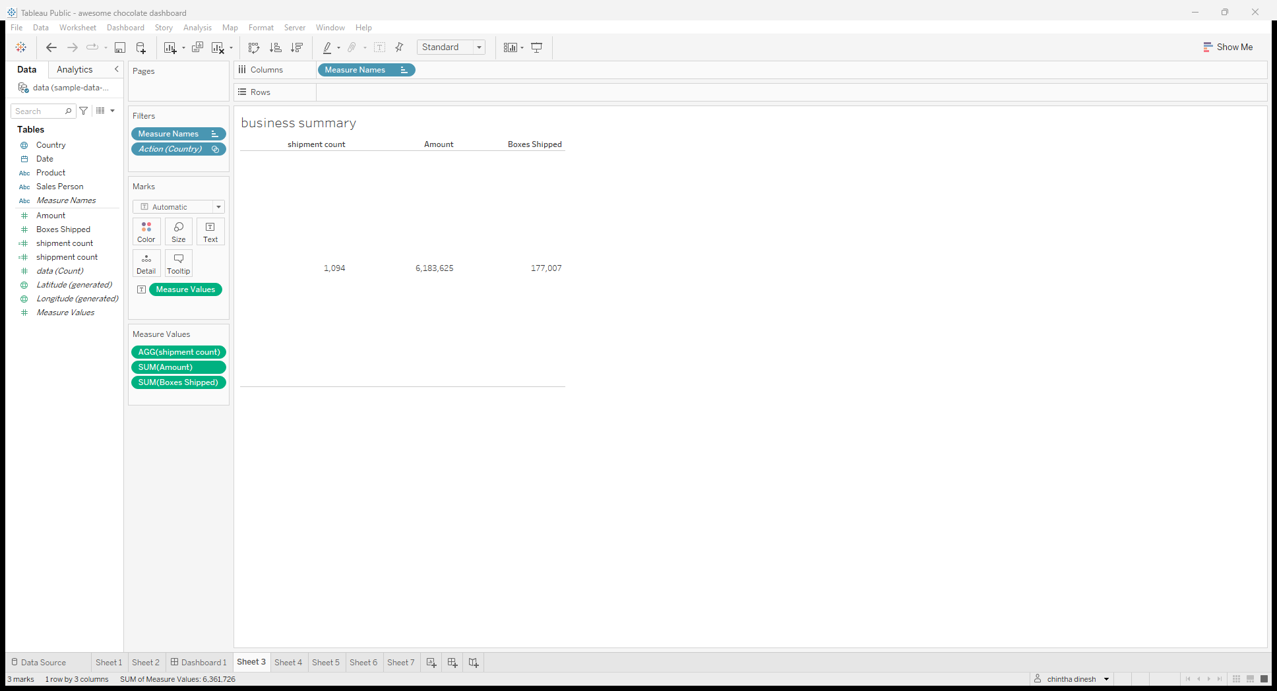

AWESOME CHOCOLATE SALES DASHBOARD

